**PROJECT REPORT**

Group Members:

* Muhammad Ahsan Bin Amir – Cs211021
* Ali Asad Rafique – Cs211035

This Project of Hospital Management System is include a Startup Window, a Login Page, a Home Page Window, Doctor Information, Patients Information, Payment Information and Staff Contact Ext. Window.

All the windows are undecorated and have jButtons for EXIT.

The Whole code in original and is subject to copyrights.

Startup Window

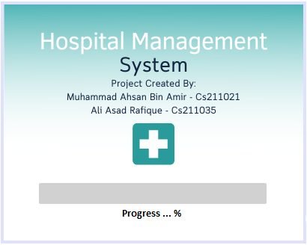

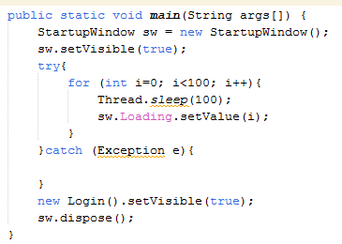

In this block of code the progress bar increments from 0 to 100 and then opens the Login window and closes itself.

Login Window

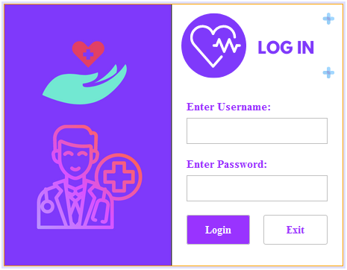

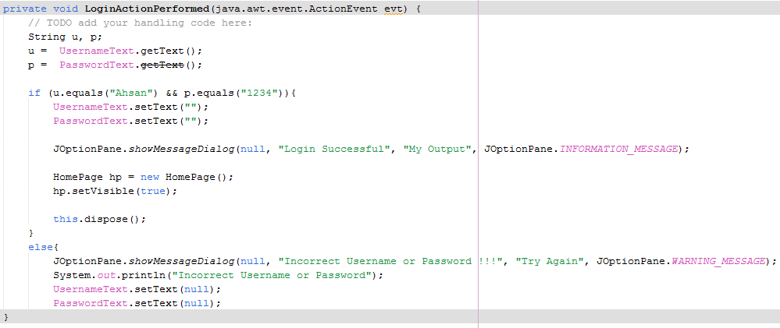

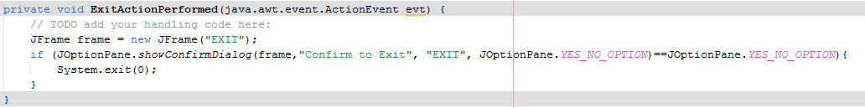

This is the Login Window with a Final Username and Password of the only Admin.

(Username: Ahsan || Password: 1234)

HomePage Window

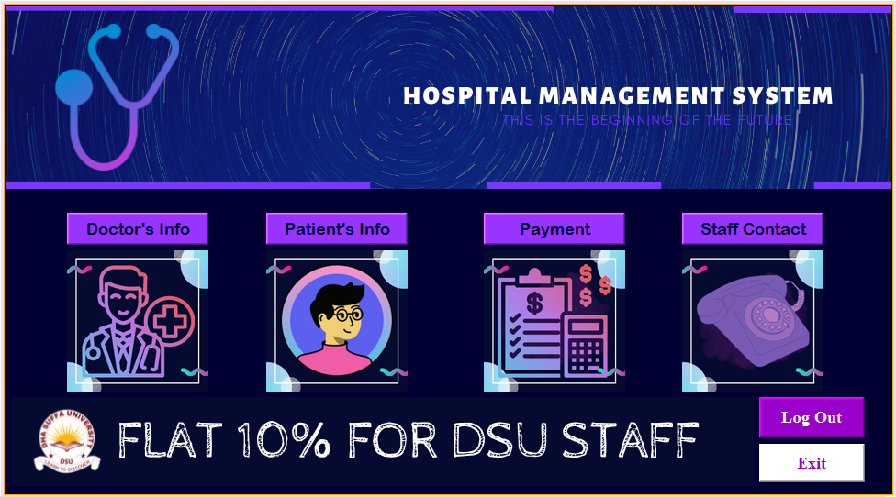

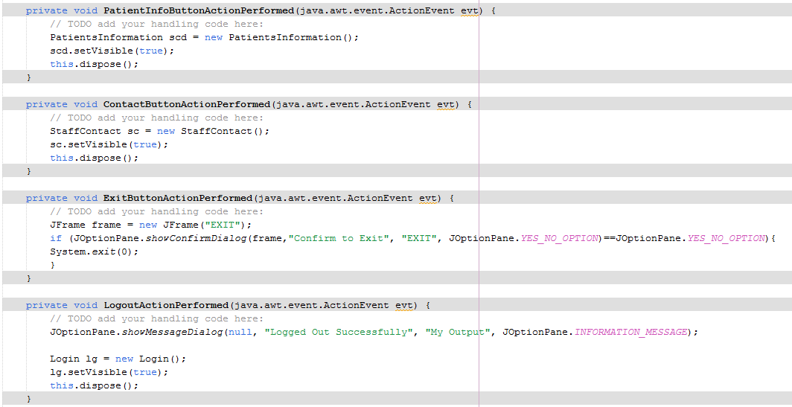

This is the HomePage, and also the menu of the management system, it is linked to each and every Window of the System.

DOCTORS INFORMATION WINDOW

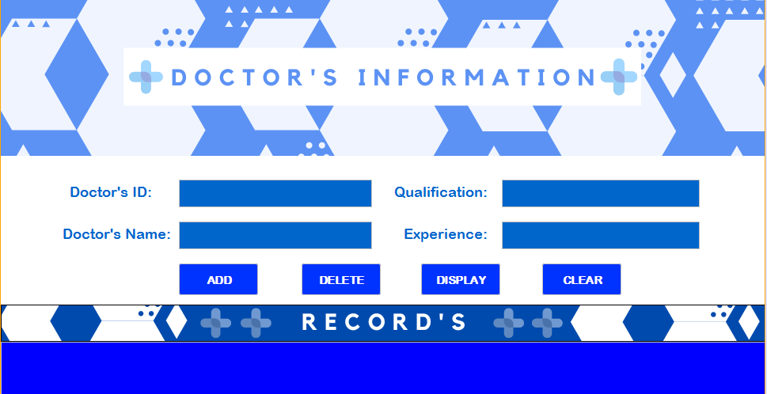

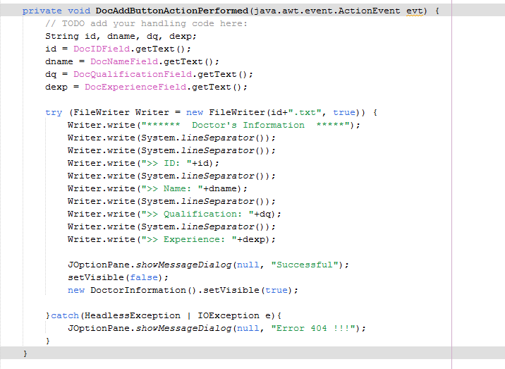

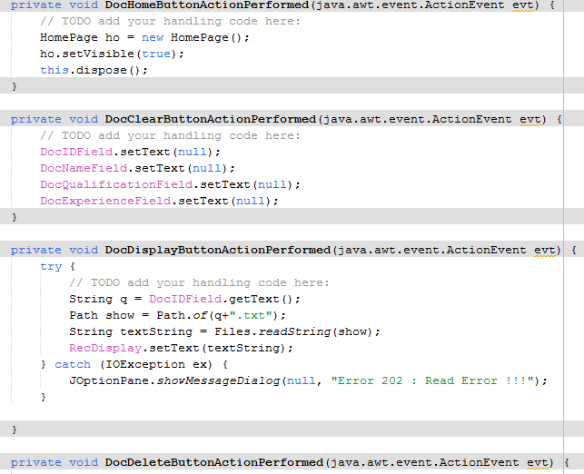

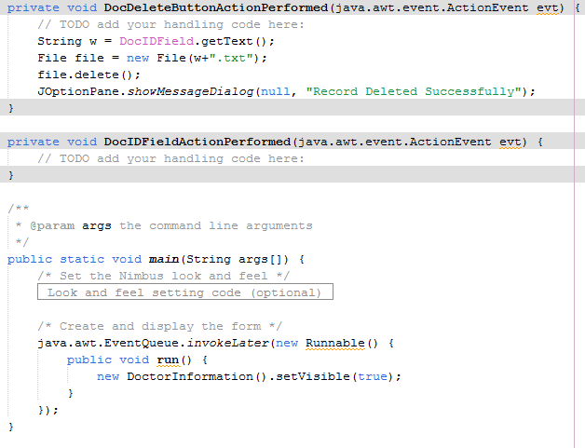

In this program each file that is saved will be saved with the name of ID as txt file. Each record will have a new and individual file.

There are buttons to display the info saved by calling it by the docID only on the text area named as RecDisplay.

DOCTOR’s INFORMATION WINDOW

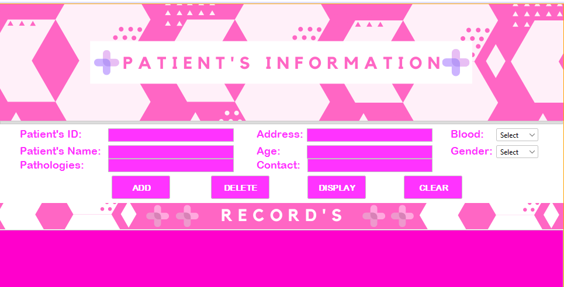

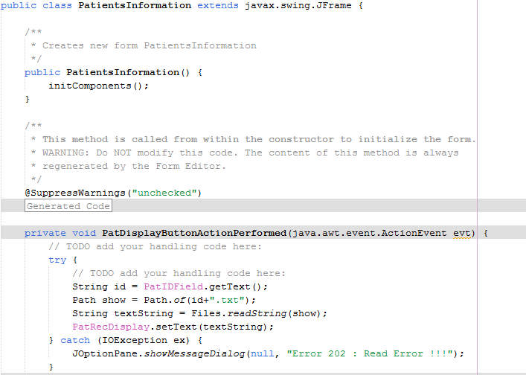

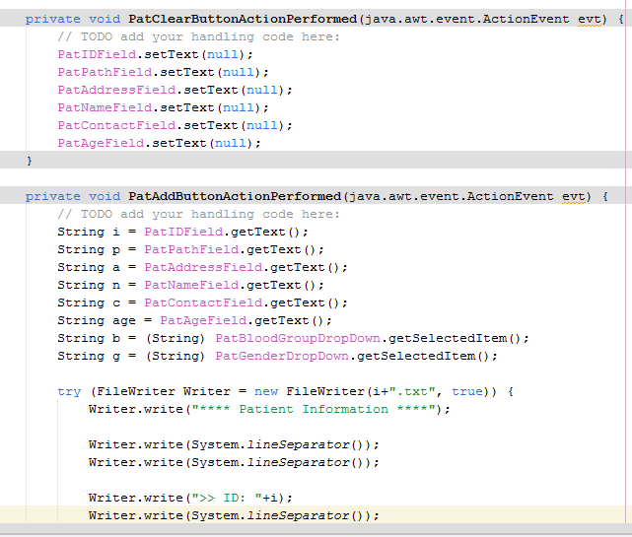

This Window is similar to the Doctors Information Window and has all its features.

PAYMENT INFORMATION

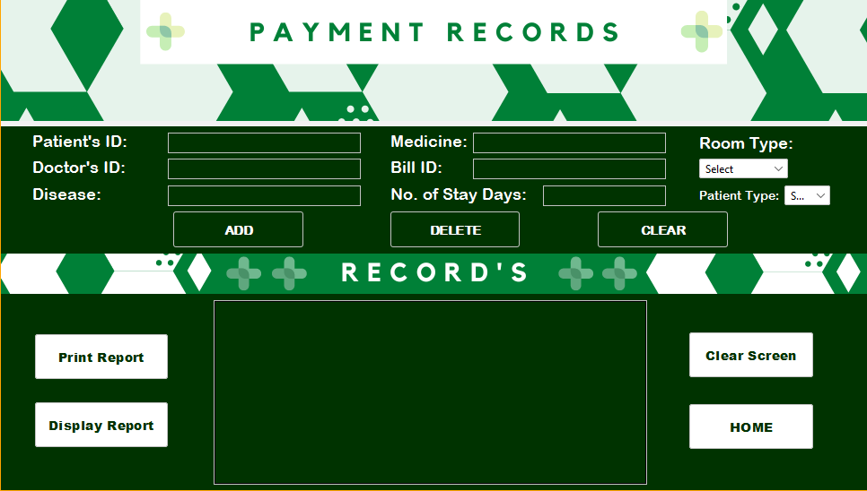

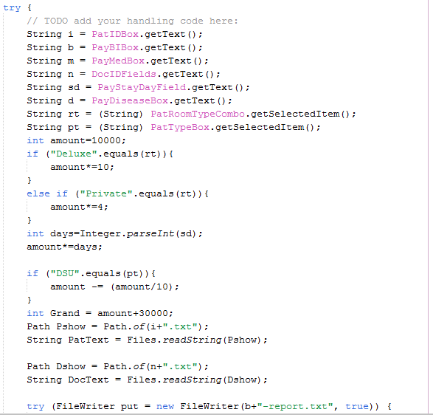

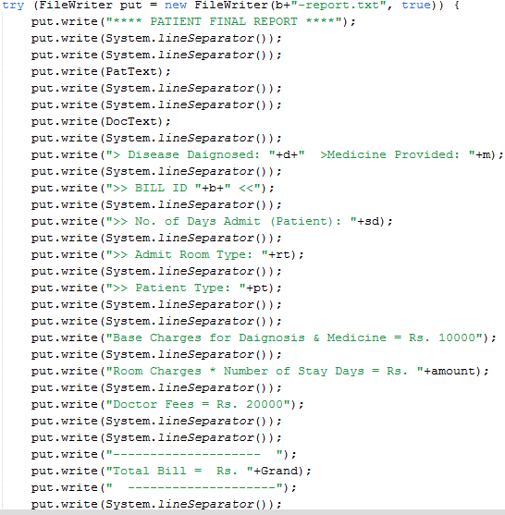

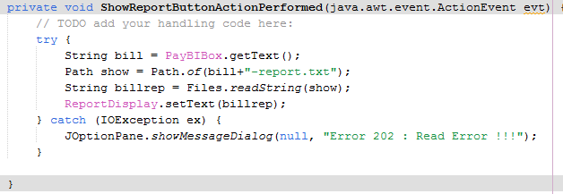

This Window also works the same as Doctor and Patient Information.

The Only difference is that it calculates the bill and displays it on the text Area box and can also print the text area via printer.

**STAFF CONTACT WINDOW**

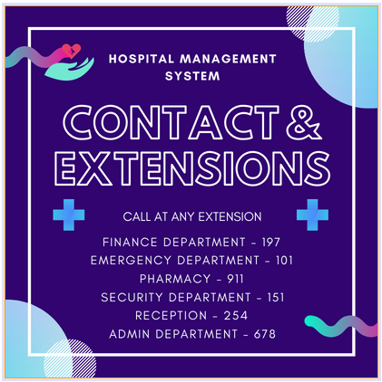

This window has a fixed image on the whole panel in a label and to go back to HomePage Window, we can click on the image anywhere to be redirected.

THANK YOU